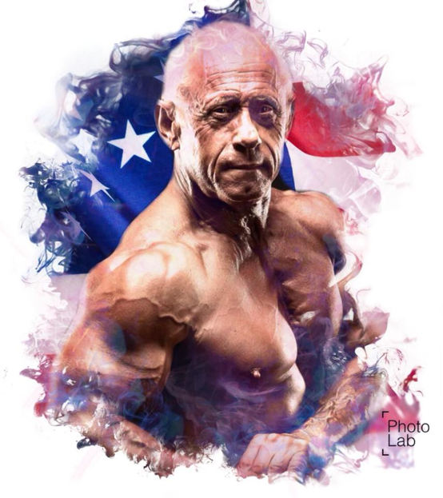
Biography Douglas E. Graham, Lt Co, USAF, (ret), MHSM
Competitive Bodybuilder
High Energy Labs

Doug is a competitive bodybuilder and is regarded as an elite amateur athlete. His next level goal is to become a professional bodybuilder. He has trained hard since 2008 and has been competing locally in Utah and Nationally for the last five years. He is the author of over 170 articles related to bodybuilding, training, nutrition, motivation, goal setting, and discipline. He continues to prepare for competition and to share his hard-acquired wisdom in the art of developing great fitness and bodybuilding. He is a retired Air Force Lt Col with over 35 years-experience as a Physician Assistant with a residency in Emergency Medicine and Trauma. He is a Health Personnel & Police Analyst and has worked on the Staff of the Air Force Surgeon General. Currently, he is the President and CEO of Pacific Medical Assets, Inc.

Core Competencies:
Weight Training
Conditioning
Nutrition (Off Season and Show Prep)
Show Prep Training and Posing
Clinical Medicine with a Specialty in Emergency Medicine
Budget Management
Project Management & Execution
Pace Setting & Leadership Development
Technical Writing
Concept Development

Education

1978 - Graduated from the Howard University Physician Assistant Program (BS/PA)
1992 - Masters Degree in Health Services Management from Webster University
1985-1988 – Masters & Doctoral work in Health Policy Science at the University of Maryland
19898-1990 - Completed Squadron Officer School, Little Rock Air Force Base, AR
1990 - Advanced Cardiac Life Support from Heart House, Bethesda MD
1991-1992 - Air Command & Staff College, Randolph Air Force Base, Texas
1980 - Fellowship/Residency in emergency medicine, University of Iowa College of Medicine

